

ASSET VERIFICATION AND RECORDING TOOL KIT


Plot 31, Bukoto Street
P.O Box 7657, Kampala, Uganda
+256 (0) 39 2000216/0772525235
email: cpa@cpa.ug

www.cpa.com

August to September 2026

VERIFICATION DETAILS

NAME OF THE REGION: | BUGANDA
SUB-REGION: | CENTRAL
Name of Local Government | KIBOGA DISTRICT
VERIFIER PARTICULARS
Full name | FATUMA YASIN,NAKAGWA HINDU,NAKITENDE SHARIFA
Contact/ email and Telephone | fatmayasin16@gmail.com  0703480094
Supervisor/ Sub team leader | FATUMA YASIN
Name | DEPAUL
Contact | 0788483159
Date of submission

HEALTH CENTRES
INFORMANT INTERVIEW/DISCUSSION GUIDE (INCHARGE OR RESPONSIBLE PERSON)

Name of Health Centre: ……………BULAGA HEALTH CENTRE III…………

1a | Does the Facility have a record of all assets provided under UgIFT.  (Obtain a record and verify if it has the costs and numbers supplied | YES
1b | If Not ask how many were supplied and when.

2 | How does this facility Maintain (repair/service/replace) the assets provided under Ugift

The facility takes care of the repairs

3 | Does the facility take regular record about functionality/ or breakdown of the assets provided? | Yes they do

4 | How has the UgIFT support helped in service delivery in the area, any issues, challenges and any recommendations for better program implementation. | The UgIFT has consistently helped in supplying health equipment to the facility and this has eased admissions hence managing the overwhelming at the facility.  It has also helped in the accommodations of staff by building staff quarters near the facility. This has reduced absenteeism at the facility since officials are ever present at the facility.  It has also helped in good sanitation because of the increased number of assets at the facility like medical wastebins, pit latrines for patients.  Maternity wards and available equipements for labor such as labor beds and labor suits have created enough space for mothers in labor hence reducing congestion.  However, the facility has challenges which include:  - There is power shortage in the area. No socket power to operate the machines.  - There is only one desktop to take all records at the facility.  - Staff quarters are not enough to accommodate the medical staff and the facility is remote.  - There are so may equipment that are not in use due to power shortage.  Recommendations are;  - Provision of power supply to enable usage of the equipment.  - Staff quarters should be increased to enable availability of health workers.  - More computers are needed to improve record keeping.

PROCEED TO VERIFICATION AFTER THIS DISCUSSION

Health centre checklist

NAME OF LG………………………………………… NAME OF HEALTH FACILITY…………………………………………………………

Equipment/ Item | Department | Asset Number | Item  Description | Life in Months | Tag Number ( engrave no.) | Date Of Purchase | Date Placed In Service | Recoverable cost | Cost | Acc Dep Cost | Net Book Value | Ytd Deprn | Equipment status | Remarks
B.P. Machine, Digital | ANC 01 |  | It is digital, grey in color |  | No engravement |  | 10/09/25 |  |  |  |  |  | functioning | In use
02 | OPD 01
B.P. Machine (Aneroid wall mounted) | MAT |  | White in color with a gauge and a black metallic base |  | No engravement |  | 10/09/25 |  |  |  |  |  | functioning | In use
02
Autoclave 20 Liters.,Duo Operated
Bowl, Kick | MAT |  | Silver basin like bowls |  | No engravement |  | 10/09/25 |  |  |  |  |  | functional | In use
01
Bowl Stand | ANC 01 |  | Silver basin like with wheel stands |  | No engravement |  | 10/09/25 |  |  |  |  |  | functioning | In use
02 | OPD 01
Counting chamber Neubauer- Improved |  |  | Plastic colorless tins |  | No engravement |  | 24/09/25 |  |  |  |  |  | functioning | In use
01
Cupboard Steel, Lockable | ANT 01 |  | Grey in color with compartments and locks |  | No engravement |  | 24/09/25 |  |  |  |  |  | functioning | In use
02 | OPD 01
Drip Stand | IPD 04 |  | Silver with a hook |  | No engravement |  | 10/09/25 |  |  |  |  |  | functioning | In use
08 | MAT 04
ESR Stand | Store |  | Grey in colour |  | No engravement |  | 24/09/25 |  |  |  |  |  | functional | Not in use
01
Examination Couch | OPD 01 |  | Cream with a black bed |  | No engravement |  | 10/09/25 |  |  |  |  |  | functional | In use
02 | MAT 01
Examination light,LED | MAT 01 |  | Black in colour |  | No engravement |  | 24/09/25 |  |  |  |  |  | functional | 1 is not in use yet
02 | Store 01
Glucometer | Lab 01 |  | White in color with a strip tin |  | No engravement |  | 24/09/25 |  |  |  |  |  | functional | In use
02 | MCH 01
Haemoglobin Meter, Digital | Lab |  | White in color with 3 buttons |  | No engravement |  | 24/09/25 |  |  |  |  |  | functional | In use
02
Height Meter | OPD |  | Cream in color with both inch and cm readings |  | No engravement |  | 10/09/25 |  |  |  |  |  | functional | In use
01
Instrument Trolley | OPD |  | Silver in color with 2 partitions |  | No engravement |  | 10/09/25 |  |  |  |  |  | functional | In use
02
Microscope Binocular | LAB |  | White in color with a black base |  | No engravement |  | 24/09/25 |  |  |  |  |  | functional | In use
01
Otoscope | OPD |  | Silver in color with a black top |  | No engravement |  | 24/09/25 |  |  |  |  |  | functional | In use
01
Patient Screen | IPD 02 |  | Silver with blue curtain like clothing |  | No engravement |  | 10/09/25 |  |  |  |  |  | functional | In use
04 | MAT 02
Patient Trolley | OPD |  | 4 wheels with a black sponge and 2 handles |  | No engravement |  | 10/09/25 |  |  |  |  |  | functional | In use
01
Refrigerator, Basic | LAB |  | Grey in color with 2 compartments |  | No engravement |  | 10/09/25 |  |  |  |  |  | functional | In use
01
Stethoscope | OPD 02 |  | Black in color with 2 rubber tube |  | No engravement |  | 18/11/25 |  |  |  |  |  | functional | In use
04 | MCH 02
Stop Watch | MCH 01 |  | It is digital |  | No engravement |  | 10/09/25 |  |  |  |  |  | functional | In use
02 | Store 01
Stretcher | OPD 01 |  | It has 4 black wheels with two rails and a black soft sponge |  | No engravement |  | 10/09/25 |  |  |  |  |  | functional | In use
01
Stove, Gas | MCH |  | White in color 6kg |  | No engravement |  | 10/09/25 |  |  |  |  |  | functional | In use
01
Weighing Scale with Height Meter, Adult | OPD 01 |  | White in color, automated with a height and a gauge. With a black rectangular base in nature |  | No engravement |  | 10/09/25 |  |  |  |  |  | functional | In use
02 | MCH 01
Weighing Scale, Infant | MCH 01 |  | White with a basin like tray |  | No engravement |  | 10/09/25 |  |  |  |  |  | functional | One is not in use yet
02 | Store 01
Weighing Scale, Toddler | MCH 01 |  | Light grey clock like with a hook |  | No engravement |  | 10/09/25 |  |  |  |  |  | functional | 1 is not in use yet
02 | Store 01
Wheel Chair | OPD |  | Black in color with 2 black wheels, 2 foot pads and 2 handles |  | No engravement |  | 10/09/25 |  |  |  |  |  | functional | In use
01
Audio Visual Equipment
Medical Waste Bin | LAB 01 |  | Blue in color wrapped with polythene bags  And a round top |  | No engravement |  | 10/09/25 |  |  |  |  |  | functional | In use
06 | OPD 01
 | IPD 01
 | MCH 02
 | Store 01
Wall Clock | IPD 01 |  | Round and white in color with figures running from 1 to 12 and placed on the wall |  | No engravement |  | 10/09/25 |  |  |  |  |  | functional | No battery, doesn’t read correct time
04 | OPD 01
 | MCH 01
 | LAB 01
Diagnostic Equipment Set for MCH | MCH |  | Scissors and fork like silver equipment |  | No engravement |  | 10/09/25 |  |  |  |  |  | functional | In use
02
Diagnostic Equipment Set for OPD | OPD |  | Silver items that include scissors and other instruments |  | No engravement |  | 18/11/25 |  |  |  |  |  | functional | In use
02
Glassware Set, Laboratory, Basic
Hollow Ware Set, Treatment
Instrument Set, Dressing | IPD 01 |  | Contains a bunch instruments like bandages |  | No engravement |  | 10/09/25 |  |  |  |  |  | functional | In use
02 | Store 01
Instrument Set, Basic ENT | Store |  | Sealed in a container |  | No engravement |  | 10/09/25 |  |  |  |  |  | Still brand new | No ENT clinical officer
03
Instrument Set, Suture
Pulse Oximeter, Hand held | OPD 01 |  | Has a screen with a grey cable |  | No engravement |  | 10/09/25 |  |  |  |  |  | functional | 1 is faulty
02
Bed, Adult Patient with Mattress | IPD 10 |  | White with black sponge mattress |  | No engravement |  | 10/09/25 |  |  |  |  |  | functional | 3 are faulty
10
Bed, Pediatric Patient, With Mattress | Pediatric ward 02 |  | White in color with black sponge mattress |  | No engravement |  | 10/09/25 |  |  |  |  |  | functional | In use
05 | IPD 027
Bedside Locker
Cupboard, Instrument | MCH |  | White in color with blue sponge mattress |  | No engravement |  | 25/09/25 |  |  |  |  |  | functional | In use
01
Delivery Bed, Hydraulic Manual | MCH |  | White bed with a blue mattress and drip stand |  | No engravement |  | 25/09/25 |  |  |  |  |  | functional | In use
01
Oxygen Therapy Apparatus, Mininum 45L cylinder | MCH 01 |  | Huge gas cylinder with an apparatus on top |  | No engravement |  | 10/09/25 |  |  |  |  |  | functional | 1 is in use and the other kept in the store
02 | Store 01
Resuscitator Manual, Infant, with all Mask sizes | MCH 01 |  | Air bag like mask with tubes |  | No engravement |  | 10/09/25 |  |  |  |  |  | functional | In use
02 | Store 01
Resuscitator Manual, Adult, with all mask sizes | Store |  | Huge mask with a tube attached |  | No engravement |  | 10/09/25 |  |  |  |  |  | Functional but not in use | They have no patients who need them yet
02
Suction Apparatus, (Electric) | Store |  | White, with 2 bags of water and a gauge. |  | No engravement |  | 10/09/25 |  |  |  |  |  | functional | Not in use yet
02
Nebulizer, Ultrasonic | store |  | White box with a rounded plastic casing |  | No engravement |  | 10/09/25 |  |  |  |  |  | Still new | Not in use yet
01
Oxygen Concentrator, Duo Flow | Store 02 |  | Grey,2 handles on top and a cylinder also on top |  | No engravement |  | 10/09/25 |  |  |  |  |  | Still new | Not in use yet
04 | IPD 01
 | MCH 01
Bench | LAB 01 |  | Brown wooden with stands |  | No engravement |  | 10/09/25 |  |  |  |  |  | All functional | In use
04 | MCH 01
 | IPD 02
Disinfection Buckets | MCH |  | Normal buckets with rounded tops and silver handles |  | No engravement |  | 10/09/25 |  |  |  |  |  | functional | In use
06
Baby Cot |  |  | Not verified |  |  |  |  |  |  |  |  |  | Not seen
Diagnostic Equipment Set for Ward | IPD 01 |  | Sealed in a silver contain |  | No engravement |  | 10/09/25 |  |  |  |  |  | One is functional | 2 are still new in the store
03 | Store 02
Hollow Ware Set, Ward | store |  | Rectangular silver container with equipment |  | No engravement |  | 18/11/25 |  |  |  |  |  | Still brand new | Not in use yet
03
Instrument Set, Delivery | MCH |  | Not verified |  | No engravement |  | 18/11/25 |  |  |  |  |  | The set has been separated for use | In use
03
Instrument Set, Stitch Removing | IPD 02 |  |  |  | No engravement |  | 10/09/25 |  |  |  |  |  | functional | One set is still new
03 | Store 01
MVA Kit | MCH |  | Silver instruments used in delivery |  | No engravement |  | 10/09/25 |  |  |  |  |  | functional | In use
04
Stool, Laboratory |  |  | Black in color with 4 wheels |  | No engravement |  | 10/09/25 |  |  |  |  |  | functional | In use
01
Penguin Sucker | MCH 02 |  | Rubber with a Nosal like tube |  | No engravement |  | 10/09/25 |  |  |  |  |  | functional | In use
03 | Store 01
Fetoscope, Dopplar | MCH 02 |  | Silver and round with a flat bottom |  | No engravement |  | 10/09/25 |  |  |  |  |  | functional | In use
02
Bubble CPAP | Store |  | Consists of clear plastic tubes |  | No engravement |  | 10/09/25 |  |  |  |  |  | functional | In use
02
Centrifuge (Electric) | Lab |  | Rounded dome-like with metallic buttons |  | No engravement |  | 10/09/25 |  |  |  |  |  | functioning | In use
02
Kangaroo Mother Care Chair | MCH |  | Low brown leather chair with a pedal to rest feet |  | No engravement |  | 10/09/25 |  |  |  |  |  | functioning | In use
01
Radiant Infant Warmer
Haemoglobin Meter, Sahli
Delivery Bed | MCH |  | White with a black soft mattress |  | No engravement |  | 15/08/23 |  |  |  |  |  | functional | In use
01
Examination light
Instrument set, ENT Basic for HCIII
Bag Valve mask (Ambu Bag), Neonatal
Incubator
Office Chair | I.C 01 |  |  |  |  |  | 10/09/25 |  |  |  |  |  | functional | In use
07 | OPD 01
 | LAB 01
 | MAT 03
 | IPD 01
Desk | OPD 02 |  |  |  |  |  | 10/09/25 |  |  |  |  |  | functional | In use
03 | MAT 01
Filing Cabinet | MAT 01 |  | Grey in color with compartments |  | No engrave number |  | 10/09/25 |  |  |  |  |  | functional | In use
02 | OPD 01
Non Residential Buildings |  |  | Maternity block
Residential Buildings |  |  | Staff quarters

PICTURES OF ASSETS VISITED AND VERIFIED

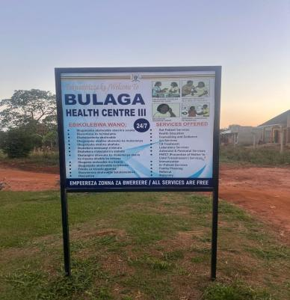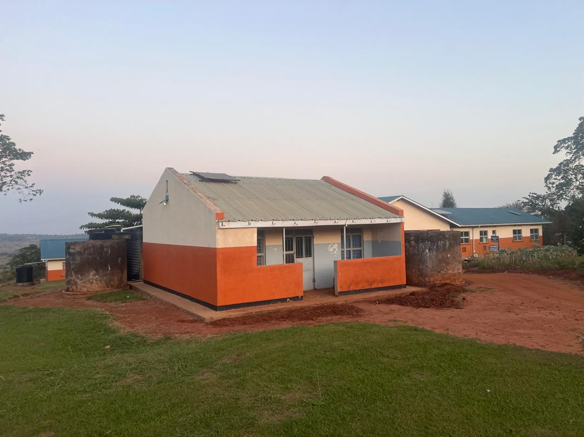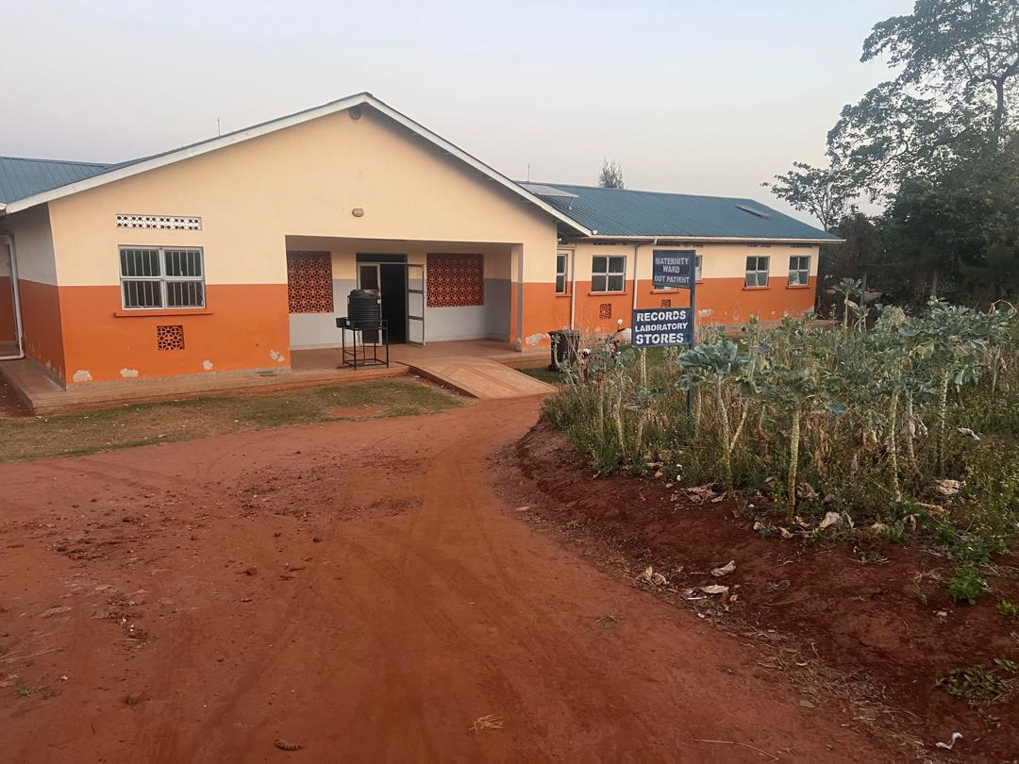

SCHOOL VERIFICATION CHECKLIST

SCHOOL INTERVIEW/DISCUSSION GUIDE

Name of school: ………………………………………………………………………………..

1a | Does the Facility have a record of all assets provided under UgIFT.  (Obtain a record and verify if it has the costs and numbers supplied
1b | If Not ask how many were supplied and when.

2 | How does this facility Maintain (repair/service/replace) the assets provided under Ugift

3 | Does the facility take regular record about functionality/ or breakdown of the assets provided?  Nonfunctional/ working, and reasons for non-functionality.

4 | How has the UgIFT support helped in service delivery in the area, any issues, challenges and any recommendations for better program implementation.

PROCEED TO VERIFICATION AFTER THIS DISCUSSION

SCHOOL FURNITURE
(School Desks, Office chairs, Laboratory stools, Book shelves)

Name of LG………………………………………………………………… Name of SCHOOL………………………………………………………………………………

Equipment/ Item | Department | Asset Number | Item  Description | Life in Months | Tag Number ( engrave no.) | Date Of Pur | Date Placed In Service | Recoverable cost | Cost | Acc Dep Cost | Net Book Value | Ytd Deprn | Equipment status | Remarks

ICT ITEMS TO VERIFY
(Desktop Computer, Server Processor, Network Switch 24 Port, Multipurpose Printer, UPS, Projector, Air Conditioners, Server, CCTV Camera)

Name of LG…………………………………………………………………………… Name of SCHOOL………………………….………………………………………

Equipment/ Item | Department | Asset Number | Item  Description | Life in Months | Tag Number ( engrave no.) | Date Of Pur | Date Placed In Service | Recoverable cost | Cost | Acc Dep Cost | Net Book Value | Ytd Deprn | Equipment status | Remarks

BUILDINGS TO VERIFY
(Non- Residential and Residential, Kitchen, Toilets/Pit latrine Water tanks, Fences etc.)

Name of LG…………………………………………………………………………… Name of SCHOOL………………………….………………………………………

Equipment/ Item | Department | Asset Number | Item  Description | Life in Months | Tag Number ( engrave no.) | Date Of Pur | Date Placed In Service | Recoverable cost | Cost | Acc Dep Cost | Net Book Value | Ytd Deprn | Equipment status | Remarks

